|  |  |
| --- | --- |
| cetlogo ***CHEMICAL ENGINEERING TRANSACTIONS***  ***VOL. 92, 2022*** | A publication of  aidiclogo_grande |
| The Italian Association  of Chemical Engineering  Online at www.cetjournal.it |
| Guest Editors: Rubens Maciel Filho, Eliseo Ranzi, Leonardo Tognotti  Copyright © 2022, AIDIC Servizi S.r.l. **ISBN** 978-88-95608-90-7; **ISSN** 2283-9216 | |

Techno-economic evaluation of creole avocado biomass valorization via oil production in North-Colombia

Tamy Herrera, Vianny Parejo, Ángel González-Delgado\*

Nanomaterials and Computer-Aided Process Engineering Research Group (NIPAC), Chemical Engineering Department, Faculty of Engineering, University of Cartagena, Cartagena 130015, Colombia

agonzalezd1@unicartagena.edu.co

Oil content in avocado has motivated the search for waste recovery alternatives that can improve the sustainability of the processing chain. As a way to take advantage of it, this avocado can be used for the production of value-added products. Therefore, it is necessary to evaluate the viability under sustainability criteria for large-scale avocado oil production in the north Colombia region, the main pantry of the Criollo-Antillean variety (Laurus Persea L) in the country. This work aims to evaluate the economic viability of the valorization of the ripe Antillean Creole avocado for oil extraction under North-Colombia conditions. The economic evaluation was carried out for a plant production capacity of 10,605 t/y mature avocado and 1,000.67 t/y of avocado oil remove. The raw material used to supply the plant is ripe avocado rejected for human consumption, which lowers the feedstock price. The economic analysis suggests a total capital investment (TCI) of $ 6,433,363 approximately and a net present value of $74.00 with a recovery of the investment after the seventh year since the project started. Besides, profits are greater than expenses since the cost-benefit ratio calculated was considerable larger than one. Results obtained show that equipment cost is critical in total capital investment calculations.

* 1. Introduction

In Colombia, the avocado harvest and production became larger latest years due to rising demand in international markets and dissatisfied intern requirements. Regardless of expansion in cultivated areas, the production method is bounded by suitable technological assistance and farming proper fields for each avocado class (Ramírez et al., 2018); however, Montes de Maria municipality is appreciated as a major land for sowing which stands out for avocado production (Marsiglia et al., 2018); however, due to the lack of adequate crop collection and distribution techniques, part of the harvest is riped and depleted without being used for the industry. (Prada, 2016). Avocado fruit is composed of a single seed, skin, and pulp; moisture and fatty acid content differ from 5 to 30 % (Yahia, 2012). This fruit is abundant in nutrients and owns elevated lipids content in the flesh that is an adequate raw material for oil extraction (Tan et al., 2018), is mostly constituted of monounsaturated and polyunsaturated fatty acids including oleic acid, palmitic acid, and linoleic acid. The above, grant properties to avocado oil to be effectively absorbed by the human body, because of its medicinal attributes (Liu et al., 2021).

Avocado oil could be obtained using physical, biological, and chemical techniques such as solvent extraction, cold pressing, critical fluid extraction, biological method-enzyme assisted, among others (Lopez et al., 2021). Moreover, organic solvents for oil extraction demand a refining stage that predominantly aims for cosmetic application (Pérez et al., 2021); for this reason, it is important to generate valorization alternatives and evaluate its economic development. In this work, the evaluation was developed from a technical-economic perspective for the production of Criollo-Antillean avocado oil (*Laurus Persea L*) harvested in the Montes de Maria region. Economic feasibility was estimated to know the avocado oil plant width using hexane as a solvent; besides, the production capacity of annual sales, equipment expenses, type of process, interest rate, raw material, among other aspects that were considered to determine Total capital investment under north-Colombian conditions.

* 1. Materials and methods
     1. Process description

The process was designed considering literature information available for avocado oil extraction, processing capacity plant was established at 10,500 t/y. For this process, the solvent oil extraction method is applied using hexane. As shown in figure 1, raw material is washed in a sodium hypochlorite solution to remove dirt and pathogens (Sandoval et al., 2010). Once the avocado is clean, proceed to pull out the peel (stream 6) and this is carried to a washing stage to recover the peel remain pulp. In the pulp extraction stage, the seed is separated and sent to wash (stream 8) to obtain the clean seed and a pulp-water mixture. The pulp obtained from the extraction stage (stream 7) is mixed with the remaining pulp from the washing stages (stream 17) and homogenized; then, it leads to the drying stage where excess water and moisture are removed from the pulp since wet extraction provides low yields (Martinez et al., 1988), this operation occurs at 1 bar of pressure and 70 °C (Ariza et al., 2011) before extraction stage.

For oil extraction, hexane was selected as a solvent because it is a non-polar substance and is considered a GRAS solvent (generally considered safe); Likewise, aspects such as availability, price, the boiling point that allow easy recovery in evaporation, in addition to being non-hygroscopic, were taken into account (Mgoma et al., 2021). The oil extracted and separated in the distillation stage (stream 26) is refrigerated at room temperature to avoid oxidation processes favored by high temperatures (Robayo, 2016), a production of 1000.06 t/y is obtained; crude avocado oil requires to be refined previous addition into cosmetic products (Cervantes and Yahia, 2021). Hexane separated in the distillation stage (stream 28) is condensed and recirculated in the process.

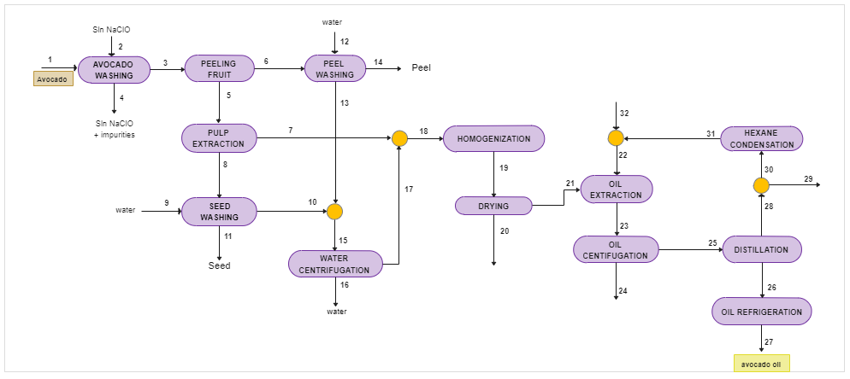

Figure 1: Creole avocado oil extraction using hexane as solvent.

* + 1. Techno-economic evaluation

To develop the economic evaluation of the avocado oil extraction plant, the model proposed by El-Halwagi was followed, based on costs estimation and chemical processes economics; for which different equations were used to observe process behavior and profitability (El-Halwagi, 2012). To calculate primary costs as operating costs and capital investment the incoming equations were applied:

|  |  |
| --- | --- |
| $$TCI=FCI+WCI+SUC$$ | (1) |
| $$OC=DPC+FCH+POH+GE$$ | (2) |
| $$DGP=\sum_{i}{m_{i}C_{i}^{v}-TAC }$$ | (3) |
| $$TAC=ACF+AOC$$ | (4) |
| $$ACF=\frac{FCI_{0}-FCI_{S}}{N}$$ | (5) |
| $$ACR=NPV \left(\frac{i{(1+i)}^{n}}{{(1+i)}^{n}-1}\right)$$ | (6) |
| $$NPV=\sum_{n}{{{AFC}_{n}(1+i)}^{-n} }$$ | (7) |

Total Capital Investment determined the amount needed to assembly the plant Eq. (1), Operational Cost refers to necessary expenses to operate Eq. (2), Gross Profit including linear depreciation Eq. (3) (Romero et al., 2017). Total annualized costs of the process Eq. (4) can be used in break-even computations. The Annual net benefit and annual cost/benefit are represented by Eq. (5) and Eq. (6) respectively. Likewise, net present value allows adjusting the cash flows to the reference time Eq. (7) (Herrera et al., 2018). The economic indicators were also calculated, profit after taxes through Eq. (8), itr means the tax rate set by the government for income derived from the process; cumulative cash flow Eq. (9) that is related to capital investment, and process profits (Cogollo et al., 2018), miciv represents the product of product flow rate and selling price. To evaluate project incomes omitting time-value capital or interest, are considered two criteria: The payback period Eq. (10), which means the capacity to recover the depreciable FCI, and Return of investment Eq. (11) is comparable to banks interest rates. The costs of the equipment, raw materials, and products were consulted in the same source (www.alibaba.com), and the costs of utilities such as gas, steam, water, and electricity were calculated under real Colombian conditions.

|  |  |
| --- | --- |
| $$PAT=DGP\left(1-itr\right)$$ | (8) |
|  | (9) |
|  | (10) |
|  | (11) |

* 1. Results and discussion

Economic evaluation for avocado oil production process was developed considering US Dollar and 15 years plant lives as a reference, raw materials expenses were consulted trough vendors (www.alibaba.com); the plant was designed to use ripe and rejected avocado for human consumption, fruit cost was established at 36 $/t (Minagricultura, 2020), sodium hypochlorite at 164,36 $/t and hexane at 750 $/t. Bearing in mind that solvent extractions are techniques used in the cosmetic industry (Buelvas et al., 2012), the sale price for avocado crude oil was defined at 20 $/t. To carry out the assessment, it was necessary to stipulate the characteristics of the process and techno-economic assumptions described in table 1, Income taxes rate and interest rate (THE WORLD BANK, 2020) were determined from the literature. Since the plant is new, the type of process will be "Plant on non-built land", it is important to make this consideration since it affects the value of the land, the type of soil we will take as soft clay, and a contingency percentage of 30 %, the cost per hour of the operator will be 30 dollars per hour and that of the supervisor 45 dollars per hour, both with 13 salaries per year, including the legal premium established in Colombia.

Table 1: Techno-economic assumptions for creole avocado oil extraction plant.

|  |  |
| --- | --- |
| Processing capacity (t/y) | 10,500 |
| Main product flow (t/y) | 1,000.67 |
| Useful life of the plant (years) | 15 |
| Salvage value | 10 % of depreciable FCI |
| Construction time of the plant (years) | 3 years |
| Income taxes rate (ITR) | 32 % |
| Interest | 8.3 % |
| Project type | Plant on non-built land |
| Percentage of contingency (%) | 30 |
| Number of workers per shift | 15 |
| Salary per operator ($/h) | 30.00 |

Moreover, the cost of the land, construction expenses, pipes, contractor fees are observed, besides, a value is obtained for contingencies, that is, the value of money that can be used to compensate for unforeseen events, such as floods, strikes, price changes, design changes, among others. Table 2 shows the results of the costs associated with the assembly of the crude avocado oil production plant. The cost of the processing equipment is the main part of fixed capital investment estimation, for its calculation was considered the equipment required in each stage of the process such as the three washing equipment, two separators of peel and pulp, filter separator, mixer, dryer, centrifuge, flash separator, condenser, heat exchanger and extraction equipment; In addition, regard shipping and installation expenses, which involves labor costs and factors directly related to the assembly and installation of the purchased equipment. The equipment represents the highest costs compared to other factors that affect DFCI associated with the production process, for example, piping, electrical installations, instrumentation, buildings, and services facilities that include plumbing, heating, lighting, ventilation, and similar services.

Table 2: Total capital investment for creole avocado oil extraction plant.

|  |  |
| --- | --- |
| **Costs of capital investment** | **Total (US$)** |
| Delivered purchased equipment cost | 924,880.00 |
| Purchased equipment (installation) | 184,976.00 |
| Instrumentation (installed) | 73,990.40 |
| Piping (installed) | 184,976.00 |
| Electrical (installed) | 120,234.40 |
| Buildings (including services) | 369,952.00 |
| Services facilities (installed) | 277.464,00 |
| **Total DFCI** | 2,136,472.80 |
| Land | 92,488.00 |
| Yard improvements | 369.952.00 |
| Engineering and supervision | 295,961.60 |
| Construction expenses | 314,459.20 |
| Legal expenses | 9,248.80 |
| Contractors' fee | 149,553.10 |
| Contingency | 277,464.00 |
| **Total IFCI** | 1,647,858.70 |
| **Fixed capital investment (FCI)** | 3,784,331.50 |
| Working capital (WC) | 2,270,598.90 |
| Startup (SU) | 378,433.15 |
| **Total Capital Investment (TCI)** | 6,433,363.54 |

Applying the equations set out in the materials and methods section, it is possible to obtain each of the values shown in the tables, taking into account the interest and income tax rate for the year in which the economic and tax evaluation is to be carried out. The working capital investment (WCI) is recoverable at the end of the project, as is required for short-term purposes.

* + 1. Economic indicators

Table 3: Economic indicators for creole avocado oil extraction plant.

|  |  |
| --- | --- |
| **Costs of capital investment** | **Total (US$)** |
| Gross Profit (depreciation not included) (GP) | 5,245,216.62 |
| Gross Profit (depreciation included) (DGP) | 4,999,093.72 |
| Profit After Taxes (PAT) | 3.399,383.73 |
| Cumulative cash flow (CCF) (1/year) | 0.81 |
| Payback period (PBP) (years) | 1.11 |
| Discounted payback period (DPBP) (years) | 5.81 |
| %ROI | 52.84 |
| NPV (MM$) | 74.00 |
| **Annual cost/Revenue** | 8.80 |

Results of techno-economic analysis for avocado oil production under specific assumptions are present in table 3; return on investment (ROI) is analogous to the interest rates of banks and the return on investment of investments in financial markets, therefore, the larger the more attractive the project will be. Additionally, the Net present value was obtained, which cumulative value is adapted to reference time; present time can be considered as process operation inception (Alsuhaibani et al., 2020). The payback Period (PBP) is an indication of how quickly the project recovers the initial fixed capital investment; while the discounted payback period (DPBP) offers a more accurate estimate of the time required to recover the depreciable fixed capital investment (FCI) from the accumulated cash flows of the project. An investment recovery period of 4.5 years was calculated in the study carried out for the production and commercialization of avocado oil for cosmetic use in Bogota city (Puentes et al., 2018); the value that differs in a period greater than one year from what was found in this study. Besides, the NPV of both projects has a close value above $70,000,000; however, these projects use different extraction methods to obtain the avocado oil even though the purpose is the same, the cosmetic industry. Figure 2a demonstrates NPV behavior over time, the process begins to have a positive net present value from year 7; after this period, it is possible to recover the investment from the project. If NPV started to be positive near the last period of the project, it would be more difficult to recover that expenditure.

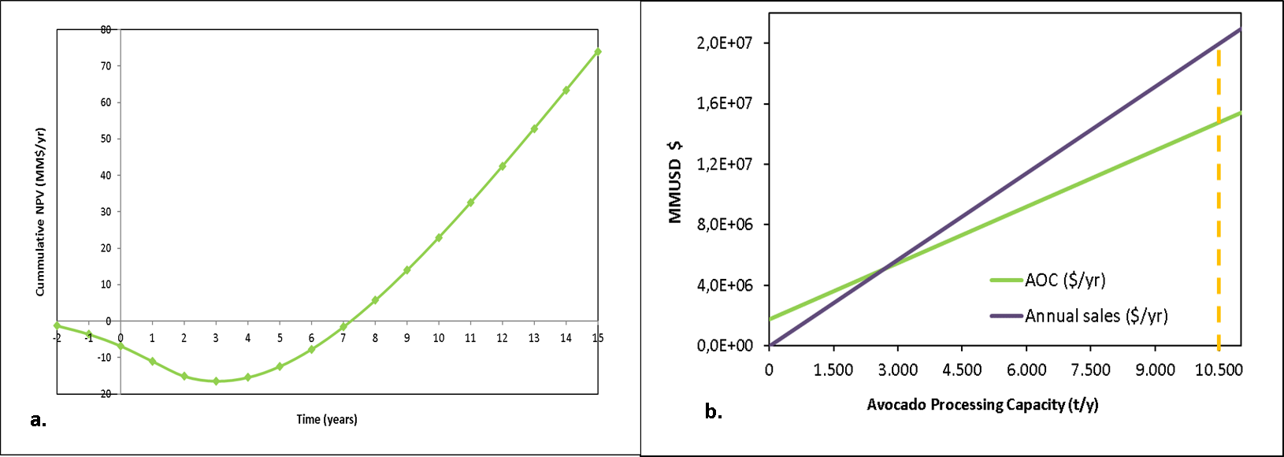

Figure 2: a) Net Present Value for oil production. b) Break-even production capacity.

To assess how the process is affected by modifications in raw material expenses and sales price, an economic analysis was performed as represented in figure 2b; which shows the equilibrium production capacity for the avocado oil production process, for an installed capacity of 10,500 t/y. An equilibrium production capacity close of 3,000 tons per year was obtained, represented by the intersection of the two lines. An installed capacity far from this intersection indicates that the process may face a decrease in its processing capacity due to low avocado production and that this will not cause significant effects on the process.

* 1. Conclusions

Considering a processing capacity of 10,500 t/y and main flow production of 1,000.67 t/y; this study found that equipment cost is critical in the Direct Fixed Capital Investment calculation. The process is feasible from a technical and economic point of view since it is possible to operate the plant close to its maximum capacity. Total Capital Investment (TCI) was determined proximate to $ 6,433,363 USD and the process recovers the initial investment in about 6 years, with a positive NPV calculated at $ 74.00 USD. In addition, economic indicators aid to identify process profitability, in this study was found a favorable Return of investment of 52.84 % and an extensive, cost-benefit ratio. The Antillean Creole avocado oil extraction plant will contribute to the recovery of the fruit and avoid those mature units from becoming waste. It is recommended to assess a sensitivity analysis that studies the behavior of the process to the variation of the prices of the raw material.

Acknowledgments

Authors thank to University of Cartagena and the Colombian National Planning Department for the supply of equipment and software necessary to conclude successfully this work via Project BPIN Code 2020000100325.

References

Alsuhaibani A., Afzal S., Challiwala M., Elbashir N., El-Halwagi M., 2020, The impact of the development of catalyst and reaction system of the methanol synthesis stage on the overall profitability of the entire plant: A techno-economic study, Catalysis Today, 343, 191–198.

Ariza A., López F., Coyotl J., Ramos E., Díaz J., Martínez A., 2011, Effect of different extraction methods on the fatty acid profile in the avocado (Persea americana Mill. var. Hass) oil, Revista Venezolana de Ciencia y Tecnología de Alimentos, 2(2), 263–276.

Buelvas G., Patiño J., Cano Salazar J., 2012, Evaluación del proceso de extracción de aceite de aguacate hass (Persea americana Mill) utilizando tratamiento enzimático, http://repository.lasallista.edu.co/dspace//handle/10567/967

Cervantes B., Yahia E., 2021, Avocado oil: Production and market demand, bioactive components, implications in health, and tendencies and potential uses, Comprehensive Reviews in Food Science and Food Safety, 20(4), 4120–4158. https://doi.org/10.1111/1541-4337.12784

El-Halwagi M., 2012, Sustainable Design Through Process Integration (1st Edition). 15–61.

Herrera T., Parejo V., González Á, 2018, Technoeconomic Sensibility Analysis of Industrial Agar Production from Red Algae, Chemical Engineering Transactions, 70. https://doi.org/10.3303/CET1870339

Liu Y., Gong X., Jing W., Lin L., Zhou W., He J., Li J., 2021, Fast discrimination of avocado oil for different extracted methods using headspace-gas chromatography-ion mobility spectroscopy with PCA based on volatile organic compounds, Open Chemistry, 19(1), 367–376. https://doi.org/10.1515/chem-2020-0125

López L., Gil J., Sierra A., Hoyos J., 2021, Hass avocado oil extraction: In the way of malaxation process optimization, LWT, 152, 112312. https://doi.org/10.1016/j.lwt.2021.112312

Marsiglia R., Torregrosa E., Quintana S., García L, 2018, Application of geographic information systems for characterization of preharvest and postharvest factors of squash (cucurbita sp.) in Bolivar Department, Colombia, Indian Journal of Science and Technology, 11(9), 1–10, https://doi.org/10.17485/ijst/2018/v11i9/117914

Martínez L., Carnacho F., Rodríguez S., Romero M, 1988, Extracción y caracterización del aceite de aguacate, Grasas y Aceite, 39, 272–277. http://www.ugr.es/~fcamacho/Originales/Trabajos Publicados/GA1988.pdf

Mgoma S, Basitere M., Mshayisa V., 2021m Kinetics and thermodynamics of oil extraction from South African hass avocados using hexane as a solvent, South African Journal of Chemical Engineering, 37, 244–251. https://doi.org/10.1016/J.SAJCE.2021.06.007

Minagricultura, 2020, Boletín Semanal de Precios Mayoristas. https://www.minagricultura.gov.co/tramites-servicios/apoyos-incentivos/Documents/2020\_Transporte/AGRICOLA\_CORTE\_03-06-2020.pdf

Pérez M., Jiménez E., Rodríguez J., Ragazzo J., Ulloa J., Ramírez J., Gastón C., Bautista P., 2021, Properties of the avocado oil extracted using centrifugation and ultrasound-assisted methods, Food Science and Biotechnology, 30(8), 1051–1061. https://doi.org/10.1007/s10068-021-00940-w

Prada, M. (2016). Competitive strategies of the primary link in production chain of avocado in Montes de Maria. REVISTADE ECONOMÍA & ADMINISTRACIÓN, 13(1), 95–110. https://revistas.uao.edu.co/ojs/index.php/REYA/article/view/11/6

Puentes Y., Barragán D., Pineda A., Castañeda G., 2018, Producción Y Comercialización De Aceite De Aguacate Para Uso Cosmético En La Ciudad De Bogotá D.C, Universidad Católica de Colombia, https://repository.ucatolica.edu.co/bitstream/10983/22531/1/PRODUCCIÓN Y COMERCIALIZACIÓN DE ACEITE DE AGUACATE PARA USO COSMÉTICO EN LA CIUDAD DE BOGOTÁ D.C.pdf

Ramírez J., Morales G., Peterson T, 2018, Potential geography and productivity of “Hass” avocado crops in Colombia estimated by ecological niche modelling, Scientia Horticulturae, 237, 287–295, https://doi.org/10.1016/j.scienta.2018.04.021

Robayo A., 2016, Caracterización fisicoquímica de diferentes variedades de aguacate, Persea americana Mill. (Lauraceae) e implementación de un método de extracción del aceite de aguacate como alternativa de industrialización, Universidad Nacional De Colombia, https://repositorio.unal.edu.co/handle/unal/59451

Romero J., Vergara L., Peralta Y., González A., 2017, A Techno-Economic Sensitivity Approach for Development of a Palm-based Biorefineries in Colombia, Chemical Engineering Transactions, 57, https://doi.org/10.3303/CET1757003

Sandoval A., Forero F., García J, 2010, Postcosecha y transformación de aguacate: Agroindustria rural innovadora, Corpoica.

Tan X., Chong H., Hamzah H., Ghazali M, 2018, Comparison of subcritical CO2 and ultrasound-assisted aqueous methods with the conventional solvent method in the extraction of avocado oil, The Journal of Supercritical Fluids, 135, 45–51. https://doi.org/10.1016/j.supflu.2017.12.036

THE WORLD BANK, 2020, Real interest rate (%), THE WORLD BANK. https://data.worldbank.org/indicator/FR.INR.RINR

Yahia M., 2012, Avocado, In Crop Post-Harvest: Science and Technology (pp. 159–186). Wiley-Blackwell. https://doi.org/10.1002/9781444354652.ch8